Network Editing How-To

This document provides examples of how to use ArcGIS to edit TRANSIMS network files. It also describes how to use several TRANSIMS utility programs to convert the ArcGIS information back to TRANSIMS file types.

Revision History
1/12/07 Created by AECOM Consult, Inc.
3/20/07 Revised by AECOM Consult.Inc.

Table of Contents
1.0 Assumptions and Prerequisites
1.1 Download the Case Study Files
2.0 How to Generate ArcView Shapefiles using ArcNet
2.1 ArcNet Control Options
2.2 ArcNet Execution
3.0 How to Edit ArcNet Shapefiles using ArcGIS
3.1 Helpful Display Properties
3.2 Reviewing and Editing Data Fields
3.3 Deleting or Modifying Traffic Controls
4.0 How to Convert ArcNet Shapefiles back to Text Format
4.1 FileFormat Program
4.2 Editing Text Files and Re-Running ArcNet
4.3 Refreshing ArcGIS Maps and Indices
5.0 Network Editing Exercises
5.1 Adding Pocket Lanes and Lane Connectivity
5.2 Adding Traffic Signals
5.3 Updating Link Shapes
6.0 Troubleshooting
7.0 Frequently Asked Questions

1.0 Assumptions and Prerequisites

This document assumes that the modeler has installed TRANSIMS Version 4.0 on a Windows or Linux computer system and understands the basic procedures and terminology for executing TRANSIMS programs.

The TRANSIMS software and documentation can be downloaded from http://transims-opensource.net → Downloads → TRANSIMS Software. Basic TRANSIMS procedures and terminology are addressed in the Installation and Testing How-To at http://transims-opensource.net → Downloads → How-To.

A basic understanding of traditional transportation planning networks and link-node network concepts and a rudimentary understanding of traffic signal systems is desirable, but not necessary.

Access to ArcGIS Version 9.1 and a standard text-editing tool (e.g., vi, Pico, WordPad) or other software that can manipulate text files (e.g., Excel) are required to perform the exercises described in this how-to. A basic understanding of how to utilize ArcMap to display ArcView shapfiles is helpful but not necessary.

1.1 Download the Case Study Files

Network information from Alexandria, Virginia, will be used to demonstrate the editing procedures and concepts. To download the Alexandria data to your computer or local area network, select http://transims-opensource.net → Downloads → Test Cases → Alexandria Case Study.

You should create a directory with a name such as

c:\TRANSIMS\Alexandria (Windows)
/home/TRANSIMS/Alexandria (Linux)

and then unzip the downloaded file to this directory. The following subdirectories will be created by this process:

activity
control
household
model
network/arcview
plans
results
skims
survey
trips
vehicle

The network files produced by the Network Conversion How-To are used as input to this discussion.

2.0 How-to Generate ArcView Shapefiles using ArcNet

A TRANSIMS network is defined using the following files:

Node (required)
Link (required)
Shape (optional)
Zone (optional)
Activity_Location (required)
Parking (required)
Process_Link (required)
Pocket_Lane (required)
Lane_Connectivity (required)
Lane_Use (optional)
Toll (optional)
Turn_Prohibition (optional)
Unsignalized_Node (optional)
Signalized_Node (optional)
Timing_Plan (optional)
Phasing_Plan (optional)
Detector (optional)
Signal_Coordinator (optional)
Transit_Stop (optional)
Transit_Route (optional)
Transit_Schedule (optional)
Transit_Driver (optional)
Transit_Fare (optional)

These files are related through a series of index data fields (e.g. Node ID, Link ID), and must be edited carefully so that these relationships are maintained. If the data files are stored in text format, this editing can be performed using standard text editors. If the data file contains fewer than 65,535 records, a program like Excel can provide helpful editing features.

Editing networks using text editors is difficult and tedious. Displaying the data on network maps makes review and interpretation of the network data much easier, though the data must still be edited at the individual file level to be used by TRANSIMS. This document describes how to display and edit individual data files using the ArcGIS software. The TRANSIMS utility program ArcNet is used to generate the ArcView Shapefiles corresponding to the TRANSIMS files before the network can be edited in ArcGIS.

  - ArcNet Control Options

ArcNet is capable of generating a graphic image and data table (i.e., shapefile) for all of the aforementioned TRANSIMS network files. By default, the coordinates in the node file are used to draw the point or line features used to depict each data record. In this case, links are represented as straight lines between node coordinates. If a TRANSIMS shape file is provided, the coordinates in the shape file are used to draw curved links and calculate bearings and turning movements. Data items defined using link offsets will be shown at the appropriate location along the curved link.

ArcNet provides a number of control keys that can be used to make it easier to visualize the data objects (such as parking lots and activity locations) in relation to the links. Most of these keys define “side-offsets”. A side offset is the perpendicular distance from the link centerline that is used to draw the object. Side offsets are purely for display purposes, they have no impact on TRANSIMS results.

For example, parking lots are defined in TRANSIMS using link offset and direction. If side offsets are not used, parking lot locations would be drawn on the centerline of the link. If side offsets are defined, the parking lots in the A→B direction of the link are drawn on the right side of the link and the parking lots in the B→A direction of the link are drawn on the left side of the link. This makes is easier to:

- see the parking lot;
- interpret its link orientation;
- distinguish it from the graphic used to draw the associated activity location; and
- draw the process link between the parking lot and the activity location.

The following graphic shows how side offsets can be used to enhance the network presentation.

Activity_Location_Side_Offset = 16 meters
Parking_Side_Offset = 8 meters
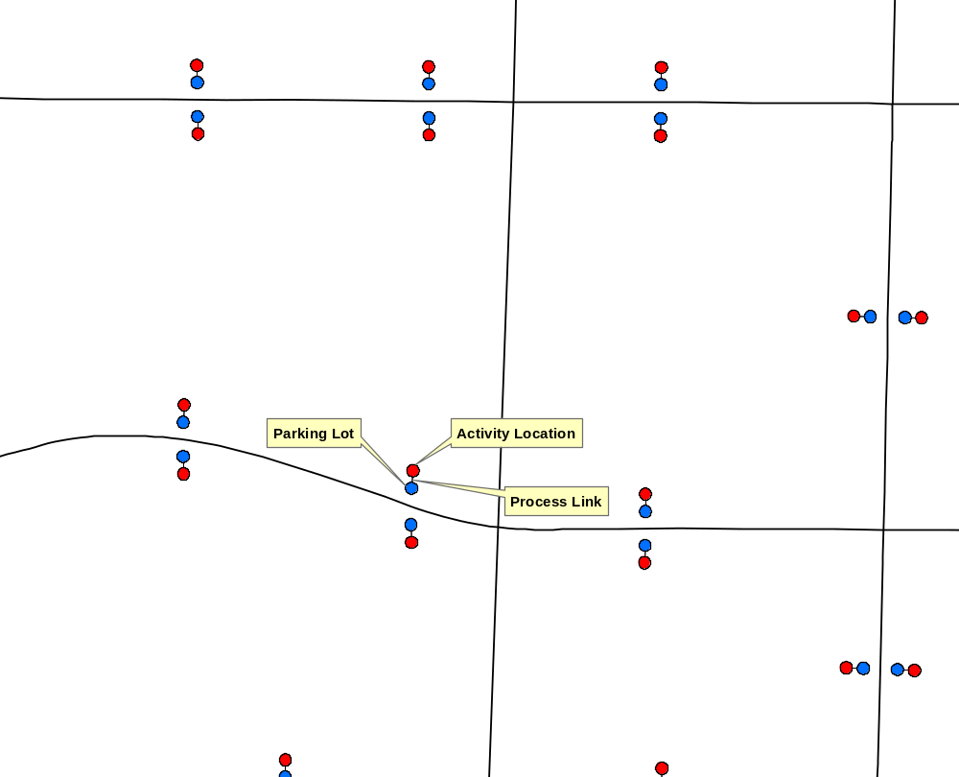

The ArcNet program also provides several ways for drawing network links. Links can be drawn as roadway centerlines or with parallel lines showing each direction of travel. The direction of travel method (i.e. parallel lines) also provides the option of drawing a line for each travel lane. Moreover, parallel lines can be drawn to the right or left of the centerline based on the one-way orientation, or centered on the centerline. If the centerline coordinates represent the center of the pavement, this will overlay aerial photos more accurately.

The following graphics show how various control parameters (keys) impact the way links are drawn. These graphics all display a one-way link with three lanes (on the left) followed by a two way link with two lanes in each direction (on the right). Note that the methods that draw lanes (cases 4 and 5) also consider the intersection setback distance, which is specified in the TRANSIMS link file (in this case, 15 meters).

Case 1:

Link_Direction_Offset = 0.0
Center_Oneway_Links = NO
Draw_Network_Lanes = NO
Lane_Width = 0.0;
Case 2:

Link_Direction_Offset = 4.0
Center_Oneway_Links = NO
Draw_Network_Lanes = NO
Lane_Width = 0.0;
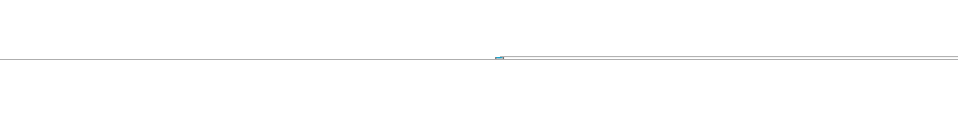
Case 3:

Link_Direction_Offset = 4.0
Center_Oneway_Links = YES
Draw_Network_Lanes = NO
Lane_Width = 0.0;
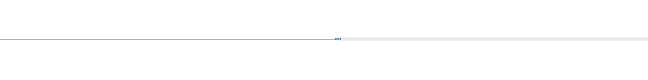
Case 4:

Link_Direction_Offset = 0.0
Center_Oneway_Links = NO
Draw_Network_Lanes = YES
Lane_Width = 3.6
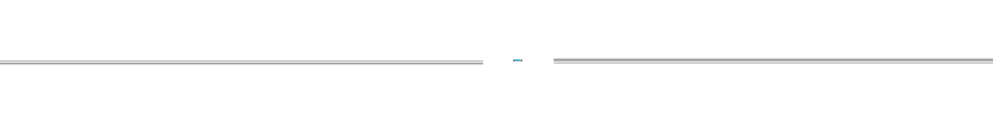
Case 5:

Link_Direction_Offset = 0.0
Center_Oneway_Links = YES
Draw_Network_Lanes = YES
Lane_Width = 3.6;
If lanes are drawn, they are also used to draw pocket lanes, lane use restrictions, and detectors. The following graphic shows how a left turn pocket lane changes the way the two-way link is drawn.
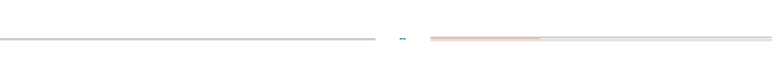

  - ArcNet Execution

The ArcView shape files generated by ArcNet can be used for a number of different purposes. Initially ArcMap (or any other GIS software) may be used to review and edit the basic link data such as facility types, number of lanes, and speeds. It can also be used to review and edit parking lots and activity locations including the relationship between activity locations and zone numbers used by the trip table conversion process. A third natural use would be to review and edit lane connectivity, pocket lanes, and signal and sign warrants to be later used to synthesize the traffic controls (refer to the IntControl utility in the Network Conversion How-To). The traffic control files can then be converted by ArcNet into ArcView shapefiles to be reviewed and edited as well. Another use would be to edit transit stops and routes, lane-use and turn restrictions by time of day, and toll facilities. Note that after network editing is finalized, the shapefiles need to be converted back into TRANSIMS format via the FileFormat utility (see Section 4.0 for detailed description).

In this exercise we will convert all of the highway related network files for final review and presentation. Two ArcNet executions will be used to generate two link-related shapefiles. One shapefile will be used to represent the link centerline. The other shapefile will display the number of lanes. In this arrangement, the centerline file will be used to edit the link data and shapes, while the shapefile with lanes is primarily used as a visual reference.

The first ArcNet step can be executed using the control file “ArcNet3.ctl” provided in the control directory. This is a text file that can be reviewed and edited using a standard text editor. The file contains the following records:

ARCVIEW_DIRECTORY ../network/arcview

NET_DIRECTORY ../network
NET_NODE_TABLE Node
NET_LINK_TABLE Link
NET_SHAPE_TABLE Shape

DRAW_NETWORK_LANES NO

The ArcNet program can be executed using one of the batch files included in the control directory:

ArcNet3.bat (Windows)
./ArcNet3.run (Linux)

A printout file, “ArcNet3.prn,” and the ArcView shapefiles “Node.shp” and “Link.shp” will be created by this process.

The second ArcNet execution also requires the TRANSIMS link file. Therefore, to avoid any confusion, the link file must be copied and renamed into “Lanes”. The control file for this step is “ArcNet4.ctl” which contains the following records:

ARCVIEW_DIRECTORY ../network/arcview

NET_DIRECTORY ../network
NET_NODE_TABLE Node
NET_LINK_TABLE Lanes
NET_SHAPE_TABLE Shape
NET_POCKET_LANE_TABLE Pocket_Lane
NET_LANE_CONNECTIVITY_TABLE Lane_Connectivity
NET_PROCESS_LINK_TABLE Process_Link
NET_PARKING_TABLE Parking
NET_ACTIVITY_LOCATION_TABLE Activity_Location
NET_PHASING_PLAN_TABLE Phasing_Plan
NET_TIMING_PLAN_TABLE Timing_Plan
NET_SIGNALIZED_NODE_TABLE Signalized_Node
NET_UNSIGNALIZED_NODE_TABLE Unsignalized_Node
NET_DETECTOR_TABLE Detector
NET_SIGNAL_COORDINATOR_TABLE Signal_Coordinator

DRAW_NETWORK_LANES YES
LANE_WIDTH 2.5
CENTER_ONEWAY_LINKS NO
ACTIVITY_LOCATION_SIDE_OFFSET 15
PARKING_SIDE_OFFSET 10

The corresponding batch files for this step are:

ArcNet4.bat (Windows)
./ArcNet4.run (Linux)

If desirable, these batch files can be modified to automatically copy the link file to “Lanes” prior to executing the ArcNet program.

3.0 How to Edit ArcNet Shapefiles using ArcGIS

The ArcNet program generates a number of ArcView shapefiles that can be displayed as layers in the ArcMap application of ArcGIS. This section provides some general suggestions about how ArcMap can be used to display and edit the shapefile representations of the TRANSIMS network.

The TRANSIMS shapefiles can be overlaid on top of aerial photos or other GIS maps to help with the editing process. If overlays are desired, the TRANSIMS shapefiles should be assigned to the appropriate UTM coordinate projection (see ArcToolbox for details). Otherwise, an “unknown spatial reference” will not affect the network editing process.

3.1 Helpful Display Properties

When a new set of shapefiles are added to an ArcMap, it is helpful to adjust the colors and symbols, and the layer order to highlight important network characteristics. The following order is suggested for the plotting the various point and polyline layers:

- Activity Location
- Parking
- Unsignalized Node
- Node
- Signal Coordinator
- Signalized Node
- Process Link
- Detector
- Lane Connectivity
- Pocket Lane
- Timing Plan
- Phasing Plan
- Link
- Lanes

The layer order can be modified by holding down the left mouse button on the layer name and dragging it to the new position.

It is also recommended to change default layer colors and symbol sizes to better visualize the data. For example, it is helpful if the color assigned to activity locations is clearly distinguishable from the color assigned to parking lots and nodes. When editing activity location data, it is particularly helpful to increase the default point symbol size from “4” to “6” (This is done by clicking the shape symbol under the Activity Location layer name).

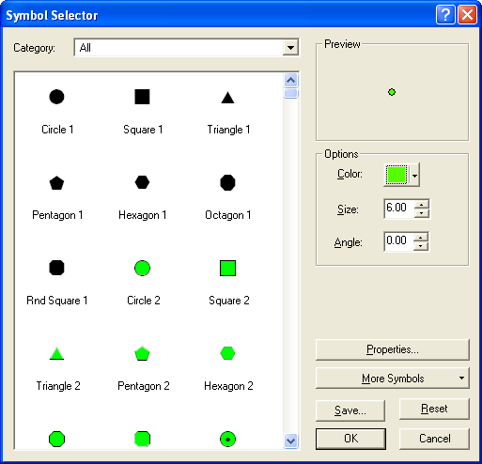
After the symbols and colors are adjusted, you can hide the activity location, parking, process link, and node layers to reduce clutter while you focus on the other layers. (This is done by clicking/removing the check mark in front of the layer name). You will also want to hide the signal layers (timing plans, phasing plans, detectors, and signal coordinators) while not in use. You will want to clearly view the lane connectivity and pocket lane layers using bright colors and line widths of about 1.7.

Now let’s adjust the link layers. The “Link” layer represents the centerline for the roadway and is the layer that should be used when editing link attributes or shapes. Let’s use a dotted orange line to make it look like a centerline strip. Click the line symbol under the “Link” layer, select a bright orange color, click the “Properties…” button, and change the simple line style from “solid” to “dotted”. Then click the line symbol under the “Lanes” layer, select “Residential Street” to set the line width to 0.2 and change the color to a light grey.

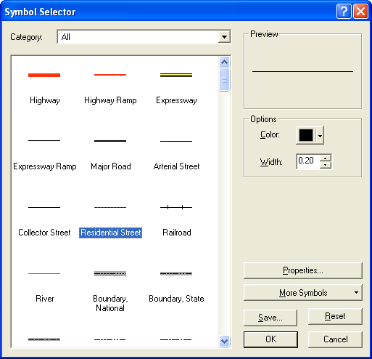
The signalized and unsignalized node layers are best displayed color coded by attribute. This is done by right clicking the layer name and selecting “Properties…” from the popup menu. This brings up the Layer Properties dialogue box. Select the “Symbology” tab, Categories, and Unique Values. For the unsignalized node layer, set the value field to “SIGN” and press the “Add All Values” button. This should generate two or three symbols. The “S” value represents stop signs so this symbol should be changed to red. The “Y” value represents yield signs so change this to yellow. If an “N” is shown, this represents “no-control”. We recommend applying the “Remove” button on this symbol. When this is done, the count for the “all other values” symbol will be increased accordingly. Remove the check mark in front of this symbol category to hide “no-control” symbols. Click OK to accept.

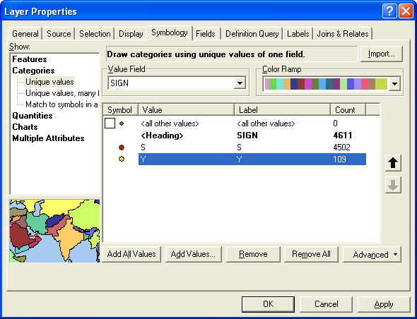

Similarly, for the signalized node layer, set the value field to “TYPE” and add all values. Two types are likely to be generated. The “A” type indicates a demand actuated signal and the “T” type indicates a fixed timed signal. Select a bright color for each of these symbols and increase the symbol size to “10” or more.

The end result should be a map that looks like the following graphic. Save the ArcMap document to “Alexandria.mxd” so it is available to subsequent sessions.

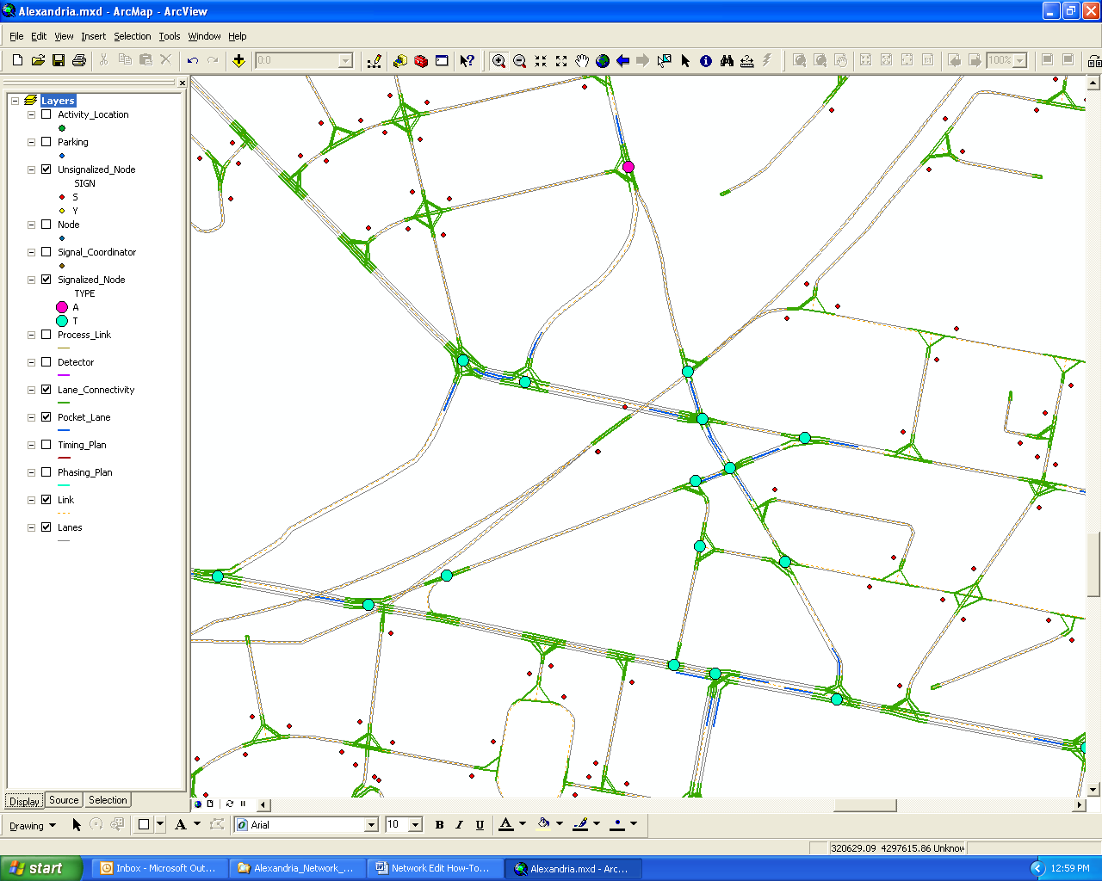

3.2 Reviewing and Editing Data Fields

Each network shapefile is associated with a table that contains all the data found in the corresponding TRANSIMS network file including any user-defined fields (note: since dBase field names are limited to 11 characters, some field names may be truncated by the conversion). Any field can be used to define symbol size or color categories to visually assist with attribute review and editing. ArcMap’s selection highlighting capability can also be helpful in finding and interpreting the data. If multiple records are drawn on top of each other, the “Identify” tool will collect all of the records at a given location and show the results in a dialogue box. By selecting each record, you can see its location on the map and its attributes in the dialogue box.

This capability is particularly helpful when reviewing lane connectivity records. Zoom into a complex intersection with lots of lane connections and use the “Identify” tool to select the lane connectivity polyline entering on one of the lanes. This will bring up a dialogue box like the one shown below. By clicking each of the lane connectivity records shown on the left side of the box, you can view the connections and the connection data. This example shows two left turn connections and one thru connection for the selected lane. This technique can be used to review the connections entering or exiting a given lane.

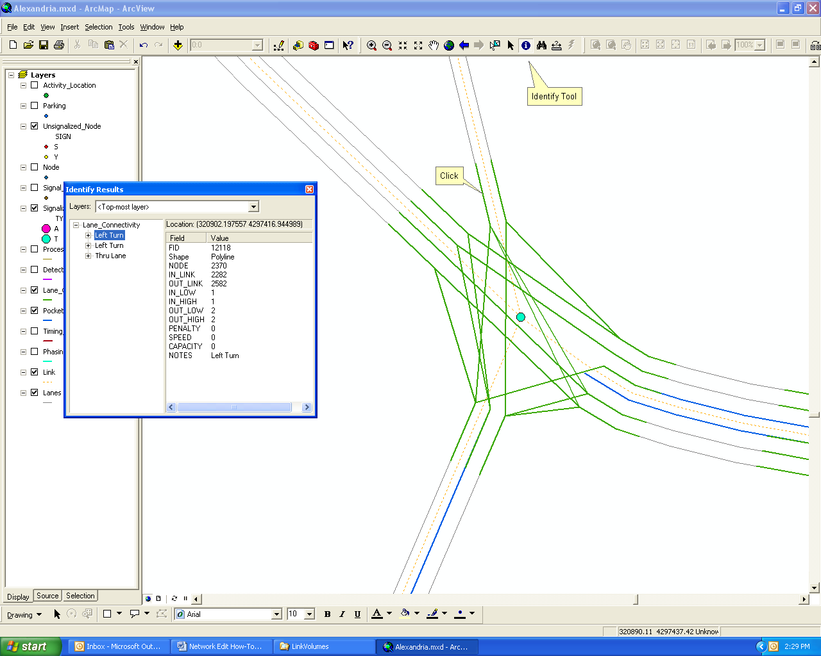

The “Identify” tool will display the data attributes of the given layer, but it does not permit you to modify the data. Editing can only take place after you start or initiate the editor. This is done by clicking the “Editor Toolbar” under the “Tools” main menu; selecting the “Editor” button on the toolbar, and then selecting “Start Editing”.

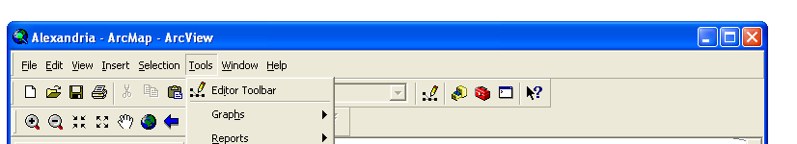

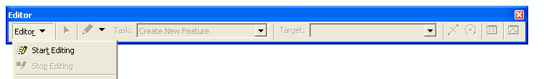

The data fields can now be modified by selecting an object with the “Edit Tool” and clicking the “Attributes” button on the “Edit” Toolbar. For example, by selecting a link and clicking on the SPEED_AB field you are able to change the speed limit of the link in the AB direction (see the figure below). None of these edits are actually saved until you select the “Save Edits” option under the “Editor” drop-down menu on the “Editor” toolbar.

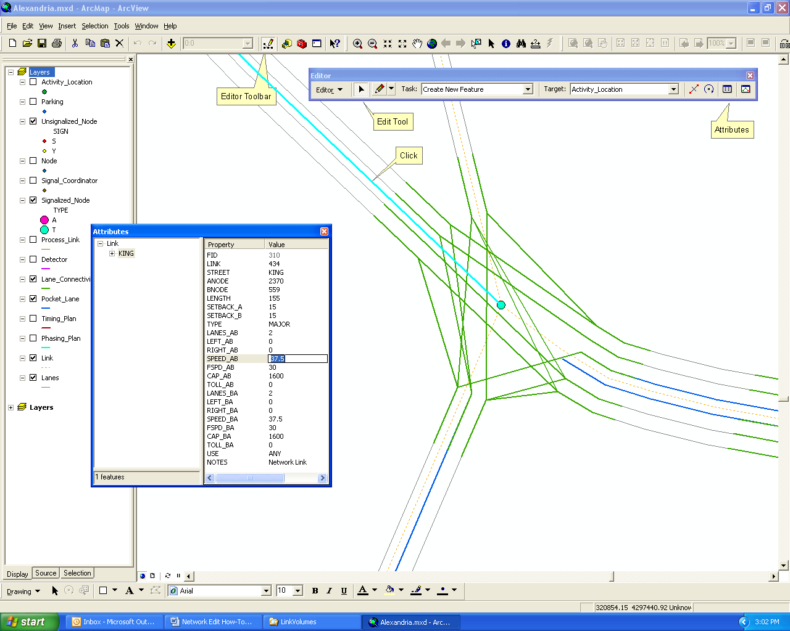

When editing field data you should pay particular attention to data fields that have relational properties. Relational fields are fields that link one data file to another data file within the TRANSIMS network system. Link and node number fields have obvious relational implications. For example, changing the Link field on the link file is likely to affect the link number codes on almost every other data file. In addition to the basic “ID” fields, there are relationships between fields like the number lanes and link length that impact the information stored in other files. It is important that you clearly understand these relationships before making changes to the data tables.

3.3 Deleting and Modifying Traffic Controls

The IntControl program was used to synthetically generate traffic controls for the Alexandria network. You will typically want to review and edit the sign and signal warrants before running the IntControl program. After IntControl has been run, deleting a signal entails deleting the associated timing and phasing plans, the detectors, and the signal coordinator. This involves deleting multiple records from five files. Instead of manually editing each record from each file, you can remove a signal and all of its associated records using a group selection approach.

The key to a group selection is to limit the ArcMap selection tool to the signal-related layers. This is done by selecting the “Set Selectable Layers…” option from the “Selection” drop-down menu. This option brings up a dialogue box like the one shown below.

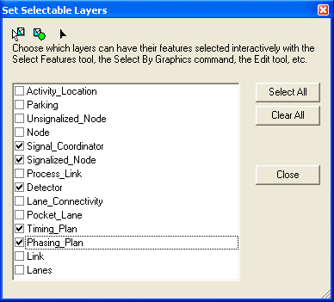

Set the check boxes to select the five signal-related files. You should also activate these five layers by checking the layer labels in the “Table of Contents” window (left side of the “Project” window). Now you can use the “Select Features” tool to select all of the signal records at a given signal that needs to be deleted. This is done by holding down the left mouse button while dragging the selection tool over the signal location. You should ensure that the selection does not pick records included in nearby signals. Alternatively, you can use the “Select by Attributes…” or “Select by Location…” options from the “Selection” drop-down menu to select a given record to be deleted.

The following graphic shows what this should look like. Notice that the lane connectivity, pocket lane, and link layers are not selected by this process. When ready, press the delete key on the keyboard.

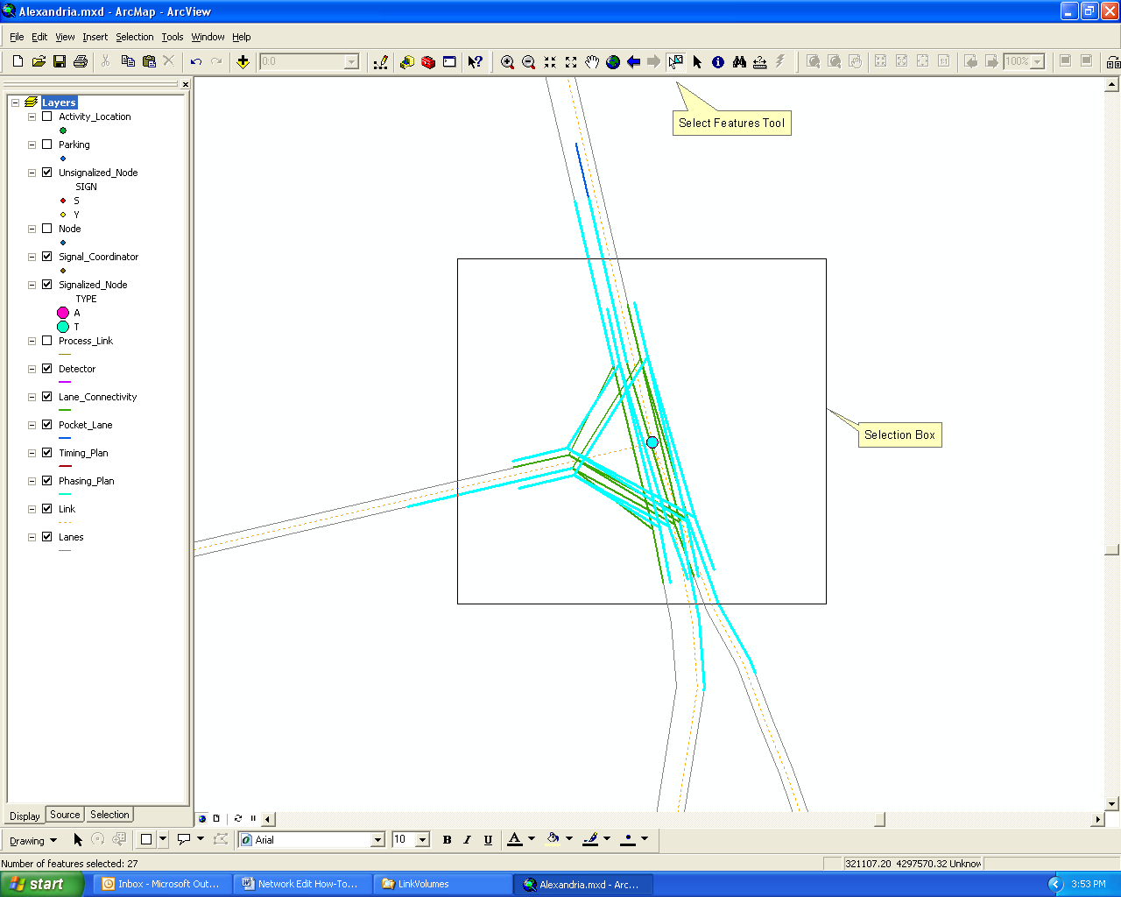

4.0 How to Convert ArcNet Shapefiles back to Text Format

One of the file formats TRANSIMS 4.0 can read is dBase. As such, it is not absolutely necessary to convert the ArcView shapefiles back to text format for use in TRANSIMS. In other words, TRANSIMS can read the dBase data table component of an ArcView shapefile directly. As long as the TRANSIMS program does not change the number of records or record order within the dBase file, ArcGIS and TRANSIMS can share the same data file.

Doing all network edits within ArcGIS is not always the most expedient way to proceed. It is, for example, often easier to copy and edit records in Excel or a text editor than creating new shapes in ArcGIS. Manual edits provide you with greater control over the record sort order that can help in tracking changes and maintaining processing performance. This section describes a relatively simple process for integrating ArcGIS and text changes to TRANSIMS network files.

4.1 FileFormat Program

The FileFormat utility is a simple program that copies data records from one file format and saves them into another file format. In this application it will be used to copy records from the dBase tables of the ArcView shapefile to tab-delimited files in the TRANSIMS network directory. Other formats include comma_delimited, space_delimited, csv_delimited, binary, fixed_column, and Version3. A sample control file is provided in the control directory and shown below.

INPUT_FILE_1 ../network/arcview/Link.dbf
INPUT_FORMAT_1 DBASE
OUTPUT_FILE_1 ../network/Link
OUTPUT_FORMAT_1 TAB_DELIMITED

INPUT_FILE_2 ../network/arcview/Link.dbf
INPUT_FORMAT_2 DBASE
OUTPUT_FILE_2 ../network/Lanes
OUTPUT_FORMAT_2 TAB_DELIMITED

INPUT_FILE_3 ../network/arcview/Node.dbf
INPUT_FORMAT_3 DBASE
OUTPUT_FILE_3 ../network/Node
OUTPUT_FORMAT_3 TAB_DELIMITED

INPUT_FILE_4 ../network/arcview/Pocket_Lane.dbf
INPUT_FORMAT_4 DBASE
OUTPUT_FILE_4 ../network/Pocket_Lane
OUTPUT_FORMAT_4 TAB_DELIMITED

INPUT_FILE_5 ../network/arcview/Lane_Connectivity.dbf
INPUT_FORMAT_5 DBASE
OUTPUT_FILE_5 ../network/Lane_Connectivity
OUTPUT_FORMAT_5 TAB_DELIMITED

INPUT_FILE_6 ../network/arcview/Parking.dbf
INPUT_FORMAT_6 DBASE
OUTPUT_FILE_6 ../network/Parking
OUTPUT_FORMAT_6 TAB_DELIMITED

INPUT_FILE_7 ../network/arcview/Activity_Location.dbf
INPUT_FORMAT_7 DBASE
OUTPUT_FILE_7 ../network/Activity_Location
OUTPUT_FORMAT_7 TAB_DELIMITED

INPUT_FILE_8 ../network/arcview/Process_Link.dbf
INPUT_FORMAT_8 DBASE
OUTPUT_FILE_8 ../network/Process_Link
OUTPUT_FORMAT_8 TAB_DELIMITED

INPUT_FILE_9 ../network/arcview/Unsignalized_Node.dbf
INPUT_FORMAT_9 DBASE
OUTPUT_FILE_9 ../network/Unsignalized_Node
OUTPUT_FORMAT_9 TAB_DELIMITED

INPUT_FILE_10 ../network/arcview/Signalized_Node.dbf
INPUT_FORMAT_10 DBASE
OUTPUT_FILE_10 ../network/Signalized_Node
OUTPUT_FORMAT_10 TAB_DELIMITED

INPUT_FILE_11 ../network/arcview/Phasing_Plan.dbf
INPUT_FORMAT_11 DBASE
OUTPUT_FILE_11 ../network/Phasing_Plan
OUTPUT_FORMAT_11 TAB_DELIMITED

INPUT_FILE_12 ../network/arcview/Timing_Plan.dbf
INPUT_FORMAT_12 DBASE
OUTPUT_FILE_12 ../network/Timing_Plan
OUTPUT_FORMAT_12 TAB_DELIMITED

INPUT_FILE_13 ../network/arcview/Detector.dbf
INPUT_FORMAT_13 DBASE
OUTPUT_FILE_13 ../network/Detector
OUTPUT_FORMAT_13 TAB_DELIMITED

INPUT_FILE_14 ../network/arcview/Signal_Coordinator.dbf
INPUT_FORMAT_14 DBASE
OUTPUT_FILE_14 ../network/Signal_Coordinator
OUTPUT_FORMAT_14 TAB_DELIMITED

Note that the link file is converted twice. Once to an output file called “Link” and the second time to the output file called “Lanes”. This is consistent with the concept of centerline and lanes files described in Section 2. All edits to the link file are made on the “Link” shapefile while the “Lanes” shapefile is used only for visual reference. The changes made to the link file are copied to the lanes file so ArcNet can keep the link information synchronized. Obviously, if the editor modifies the lanes shapefile, a different procedure would be needed to capture the changes.

The FileFormat program can be executed using one of the batch files included in the control directory:

FileFormat.bat (Windows)
./FileFormat.run (Linux)

A printout file, “FileFormat.prn,” and the updated network files will be created by this process.

4.2 Editing Text Files and Re-Running ArcNet

The new network files were stored by the FileFormat step in tab-delimited format. These files can be edited using a text editor or a program like Excel. If a text editor is used, it is important to make sure that each new record includes a tab character to separate the data fields. Copying and editing an existing record is often the safest and quickest way of adding records to the file.

Unfortunately, tab-delimited files are not always easy to read and interpret within a text editor. A spreadsheet program like Excel can eliminate this problem by keeping the fields in columns. You can also freeze the header record on an Excel spreadsheet to make it easier to keep track of the column data. Excel can also be used to sort or search for records, make global adjustments / calculations, and add data fields to the file. The only limitation is the maximum number of records in the file (i.e., 65,535). A number of TRANSIMS network files will exceed this limit for large or complex regions.

If Excel is used to make edits, save the results back to a tab-delimited format rather than as a spreadsheet. In the Windows operating system, this whole process of editing network files with a standard text editor or Excel can be simplified if a file extension is added to the TRANSIMS network files. If the traditional Linux file names of Node, Link, etc. are re-named to Node.txt, Link.txt, etc., Windows can be configured to automatically edit these files using a specified text editor or Excel. You can then simply double click the filename in the Windows Explorer to review and edit the file.

Once the files are edited, the ArcNet program should be re-run to re-create the ArcView shapefiles. It is likely that this process will find errors in the data fields of various files that will need to be addressed before proceeding. When ArcNet presents an error message, take note of the file that caused the problem and any reference information it provides. Use the text editor to locate the record and fix the problem. It may take several iterations to remove all of the errors. If the errors are in one of the foundation files (e.g., link or node), it may be desirable to comment out (add a # sign in front of the key) the related files in the ArcNet control file and only convert the link and/or node file. These files can then be repaired with ArcGIS and converted back to tab-delimited format for input to ArcNet.

4.3 Refreshing ArcGIS Maps and Indices

In most cases, it is not necessary to exit ArcGIS after each application of ArcNet. You can run FileFormat, make manual edits using Excel, and regenerate the shapefiles using ArcNet. ArcGIS won’t show these changes until the view is redrawn. This can be done by simply panning or zooming or hitting the refresh button at the lower-left corner of the “Project” window. If records disappear from view, the most likely explanation is incompatible geographic index files.

ArcGIS generates two geographic index files (*.sbn and *.sbx) for each shape file to speed up the drawing and editing processes. When ArcNet is re-run, it generates new shapefiles (*.shp, *.shx, and *.dbf) and deletes the geographic index files. If the geographic index files are not deleted, ArcGIS will attempt to use the old index with the new shapefiles, which may be problematic due to record number changes. Therefore, it is best to delete all geographic index files (*.sbn and *.sbx) before or after each ArcNet application. ArcGIS will automatically recreate these files when the editor is started.

5.0 Network Editing Exercises

This section includes a few examples of typical editing tasks that require the coordination of multiple files or the execution of TRANSIMS utility programs. In most cases you will make edits in ArcMap, run the FileFormat and other programs, re-run ArcNet to regenerated the ArcView shapefiles, and confirm the results using ArcMap.

5.1 Adding Pocket Lanes and Lane Connectivity

Adding a pocket lane is typically a multi-step process that involves changes to the link, lane connectivity, and pocket lane files. The following steps are recommended.

- Update the lane attributes in the Link file.
- Add a new record to the Pocket Lane file.
- Change lane assignments to lane connectivity records at the upstream node.
- Change and/or add lane assignments and lane connectivity records at the downstream node.

We will demonstrate these actions by adding a left turn pocket lane on Duke Street at the eastbound approach to Peyton Street. To locate this block, use the “Select by Attributes…” option under the “Selection” drop-down menu as follows:

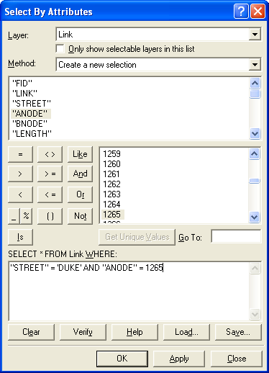

Use the “Zoom To Selected Features” option under the “Selection” drop-down menu to zoom into the block. The graphic below shows the location.

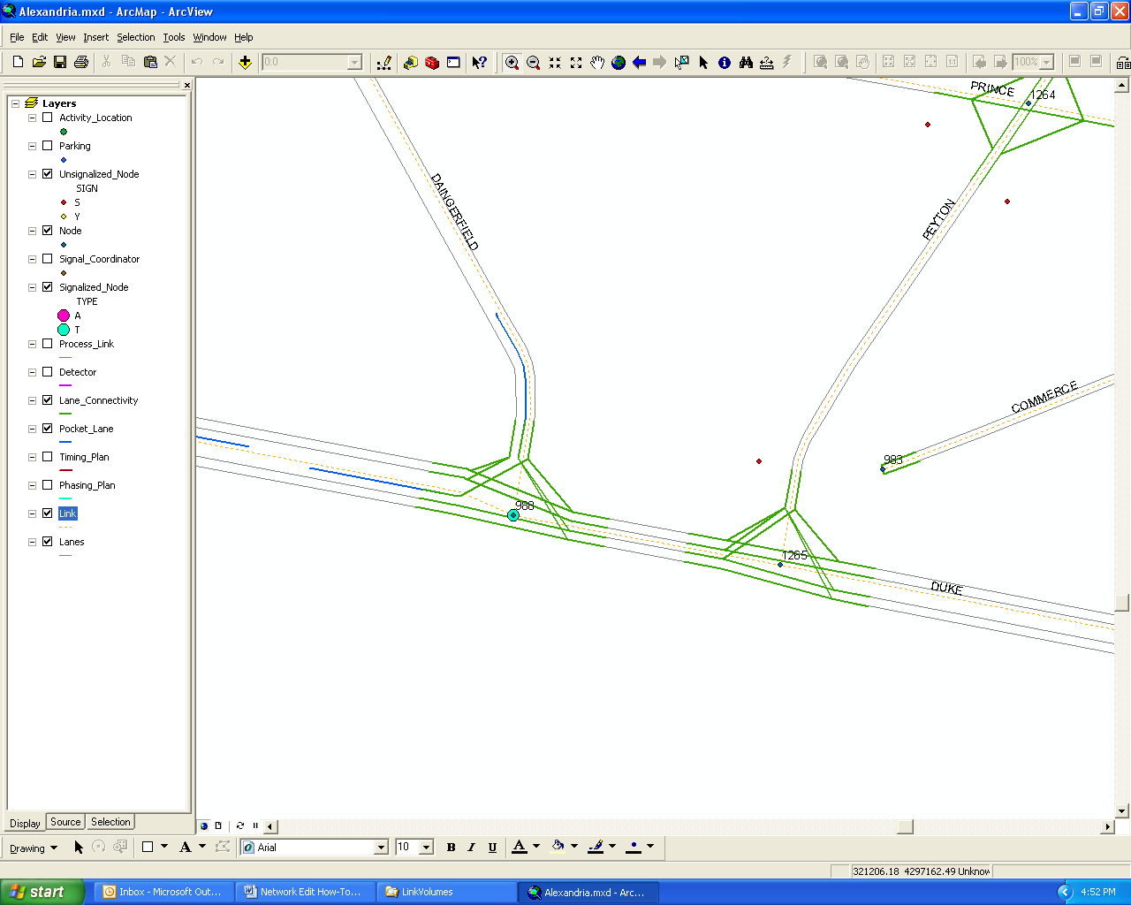

Start the editing process using the “Start_Editing” button on the Editor Toolbar. Use the “Identify” tool to select the node record where the turn pocket will be added. In this case, the node number is 1265. Now use the “Edit” Tool on the Editor Toolbar to select the link record and the Attributes tool to view the data fields. (Remember to select the centerline symbol (dotted orange line) between the two nodes rather than link lanes.) If the link is not highlighted, it may be due to the fact that you limited selection to signal-related files as part of the exercise in Section 3.3. Reset the selectable layers to all layers and try again.

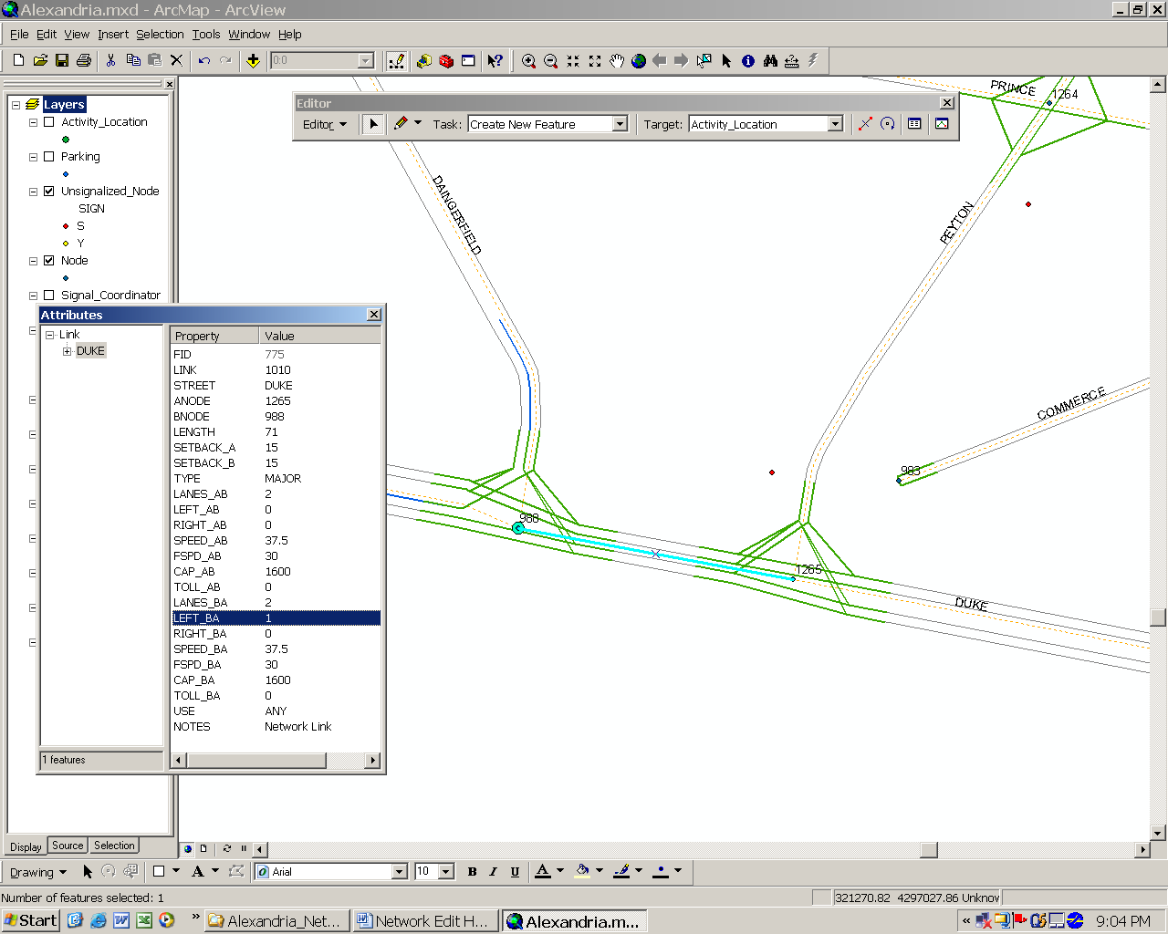

Notice that node 1265 is the A-node on link 1010. This means that the pocket lane needs to be added in the B→A direction of this link (i.e., eastbound approach to Peyton Street). To make room for this lane on the link, enter “1” in the LEFT_BA field (number of left side pocket lanes in the B→A direction). This changes the lane numbering scheme in the B→A direction of this link. Lane 1 is now the pocket lane and lanes 2 and 3 are the thru travel lanes (numbering starts from left-most lane).

Now add the turn lane to the pocket lane file. This can be done in a number of ways. You can use the Sketch Tool to draw a line to represent the pocket lane and fill in each field in the Attributes table, or you can add a record to the end of the attribute table. Note that any shape points that are entered using the Sketch Tool have no impact on the TRANSIMS data file. When ArcNet is re-run, these shape points will be replaced by a new pocket lane shape. To emphasize this point, let’s add data to the attribute table without creating a shape record. Right click on the Pocket Lane layer name on the left side of the screen and select “Open Attribute Table” from the pop-up menu. This should display a table with all of the pocket lane records. Go to the end of the table, and enter the necessary data (except the FID number automatically added by ArcMap) in the blank line at the end of the table. The results should look like the graphic below.

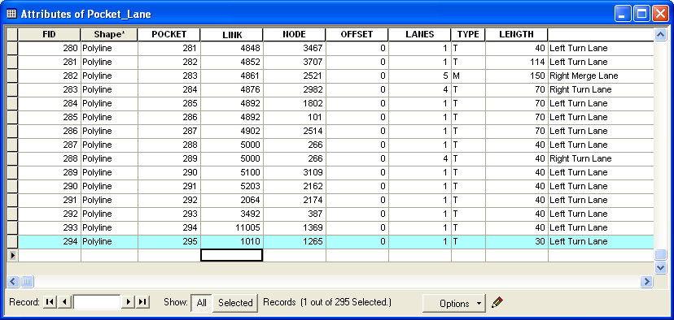

Because of the lane renumbering, the lane connectivity at the upstream end of the link (i.e., at node 988) must be updated to reflect the addition of the pocket lane at node 1265. Each connection entering link 1010 at node 988 needs to be re-assigned to a lane number that is incremented by one. In other words, lane 1 is changed to lane 2 and lane 2 is changed to lane 3. Click on each lane connection entering the link at node 988 using the “Selection” tool, click on the “Attributes” button on the Edit Toolbar, and change the OUT_LOW and OUT_HIGH (outbound lane number range) fields appropriately. The figure below shows an example.

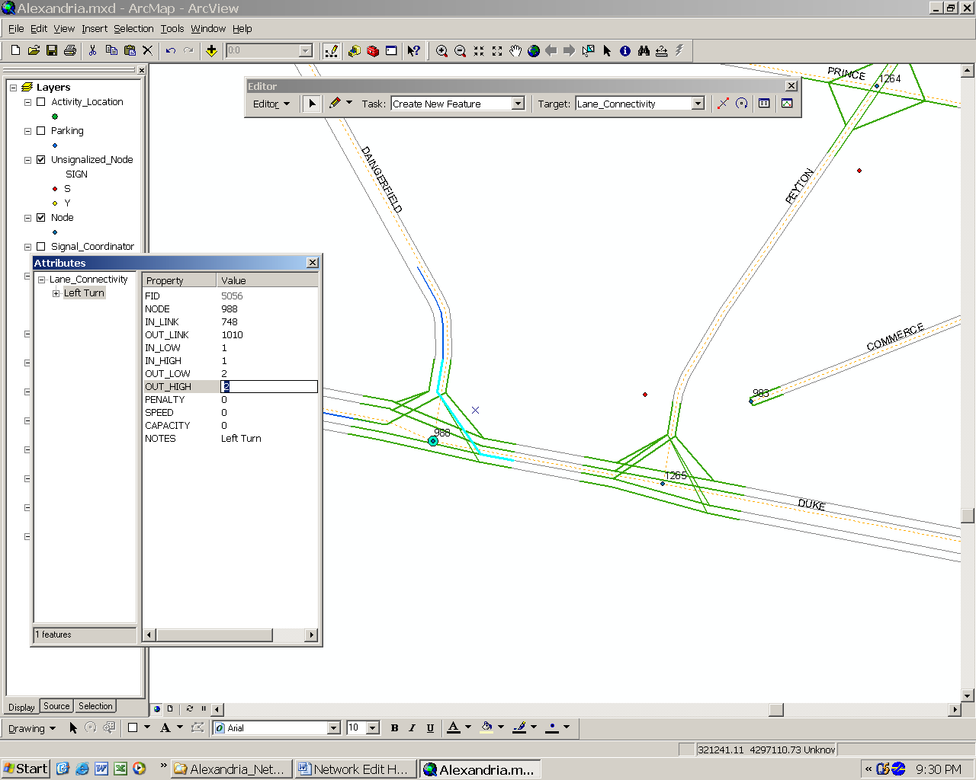

Now do the same thing to the connections exiting the link at node 1265 and modify the IN_LOW and IN_HIGH (inbound lane number range) fields appropriately. In this case, lane 1 now represents the left turn lane so at least one connection should be assigned to lane 1 in order to leave the link from this lane. Since a left turn and thru connection was provided for the original lane 1, it makes sense to leave the left turn connection on lane 1, but move the thru connections to lanes 2 and 3.

Save the changes using the “Save Edits” button, convert the files back to tab-delimited format using FileFormat utility, re-run both ArcNet3 and ArcNet4 batch files (since the link attributes are changed) and display the updated shape files in ArcMap. A new pocket lane should be shown on the link and the lane connections at both ends should be connected appropriately.

5.2 Adding Traffic Signals

This exercise uses the IntControl program to synthesize new signal data for an existing set of traffic controls. Signs can be easily added by inserting new records into the unsignalized node file directly, but signals are much more complex and frequently involve 20 or more records from 5 different data files. In this demonstration, a signal will be added to the network. The location of the signal will be specified using a text file, which will be used by ArcMap to identify the node numbers where the controls are to be inserted and then display the results.

All that is needed to specify a new signal location is the node number, the signal type, and the ring type (optional). Open a standard text editor window and enter the following tab-delimited records below, where “A” and “T” stand for actuated and timed signal type, respectively, and “S” and “D” stand for the single or dual ring controller, respectively. Save the text file as “Add_Signals.txt” in the network directory. The file should look something like the example below.

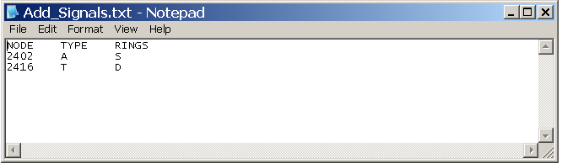

In the examples listed above, it will be necessary to delete the stop signs at these intersections before a new signal can be added. This can be done by selecting each sign using the Edit tool and pressing the delete key. Save the editing session and update the files using the FileFormat process. Then run the IntControl program using the control file “IntCotnrol2.ctl” found in the control directory. This file contains the following records:

TITLE Add Signals
DEFAULT_FILE_FORMAT TAB_DELIMITED

#---- Input Files ----

NET_DIRECTORY ../network
NET_NODE_TABLE Node
NET_LINK_TABLE Link
NET_SHAPE_TABLE Shape
NET_POCKET_LANE_TABLE Pocket_Lane
NET_LANE_CONNECTIVITY_TABLE Lane_Connectivity

NET_UNSIGNALIZED_NODE_TABLE Unsignalized_Node
NET_SIGNALIZED_NODE_TABLE Signalized_Node
NET_TIMING_PLAN_TABLE Timing_Plan
NET_PHASING_PLAN_TABLE Phasing_Plan
NET_DETECTOR_TABLE Detector
NET_SIGNAL_COORDINATOR_TABLE Signal_Coordinator

INPUT_SIGNAL_FILE ../network/Add_Signals.txt

#---- Output Files ----

NEW_DIRECTORY ../network
NEW_SIGNALIZED_NODE_TABLE Signalized_Node2
NEW_TIMING_PLAN_TABLE Timing_Plan2
NEW_PHASING_PLAN_TABLE Phasing_Plan2
NEW_DETECTOR_TABLE Detector2
NEW_SIGNAL_COORDINATOR_TABLE Signal_Coordinator2

#---- Parameters ----

CREATE_NOTES_AND_NAME_FIELDS YES
SIGNAL_CYCLE_LENGTH 60
MINIMUM_PHASE_TIME 5
YELLOW_PHASE_TIME 3
RED_CLEAR_PHASE_TIME 1
SIGNAL_DETECTOR_LENGTH 30
POCKET_LANE_FACTOR 0.5
GENERAL_GREEN_FACTOR 0.5
EXTENDED_GREEN_FACTOR 0.6
SIGNAL_SPLIT_METHOD CAPACITY
MINIMUM_LANE_CAPACITY 500
MAXIMUM_LANE_CAPACITY 1500

The IntControl program can be executed using one of the batch files included in the control directory:

IntControl2.bat (Windows)
./IntControl2.run (Linux)

You must check the printout file, “IntControl2.prn” for warning messages about signal-sign conflicts. If the application is successful, a new set of signal-related files (Signalized_Node2, Timing_Plan2, Phasing_Plan2, Detector2, Signal_Coordinator2) are created. The modeler may choose to modify the ArcNet control file to point to these new files or copy these files to the original file names. You can then run the ArcNet application to refresh the ArcView shapefiles.

5.3 Updating Link Shapes

The shape coordinates stored in the ArcView shapefiles do not impact the TRANSIMS process in any way. TRANSIMS uses the X and Y (easting/northing) coordinate fields in the node table to define most position references. Link shapes can impact the direction calculations if they are stored in a TRANSIMS shape table. This table is different from an ArcView shapefile. The TRANSIMS shape table only contains the intermediate shape points between the A-node and the B-node of the link.

If you modify the shape of a link using ArcGIS, these coordinates must be converted to a TRANSIMS shape table to have any impact. If the coordinates of the end point of a link are changed, these changes need to be made to the node coordinate fields (i.e., the dBase file). If necessary, an ArcGIS macro can be executed to copy the coordinates from the node shape to the dBase file (see the ArcGIS help system for details). This exercise will demonstrate how to use the GISNet utility to extract the shape points and node coordinates from an ArcView shapefile that represents the centerline of the link.

Start by editing the shape of a link in ArcGIS. Open the link centerline layer in ArcMap session for editing. Change the “Target” to “Link” and the “Task” to “Modify Feature” in the Editor Toolbar. Use the Edit Tool to select the link to be edited. The link will be redrawn using the selection attributes and existing vertex points will be displayed as squares. If the link currently includes shape points, these points can be moved to adjust the shape as desired. If additional vertex points are needed, right click the link at the desired location and select “Insert Vertex” from the popup window. The Edit Tool can then be used to select the vertex and move it to the desired location. An example is shown in the figure below. Save the edits and exit the program.

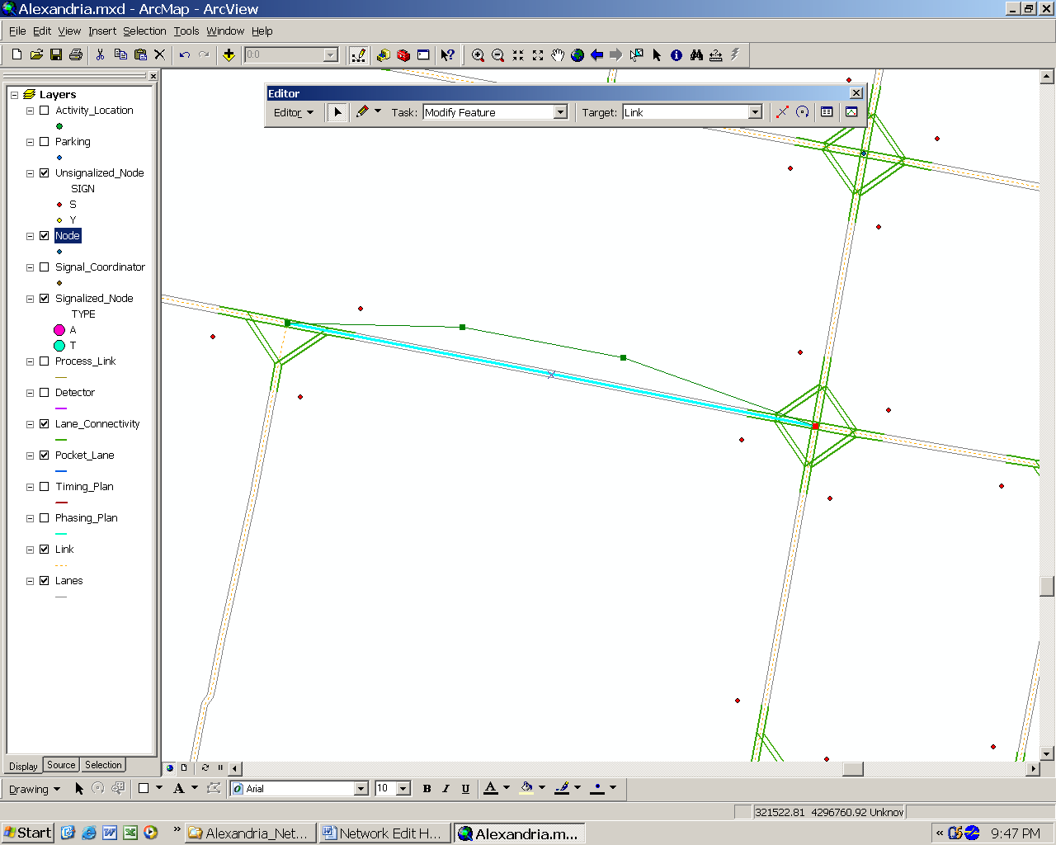

At this point, the ArcView shapefile representation of the TRANSIMS link contains additional shape points that are not included in the TRANSIMS shape file. The GISNet program can be used to extract these shape points from the ArcView shapefile and create the corresponding TRANSIMS node, link, and shape tables. A sample GISNet control file is provided in the control directory. It contains the following records:

GIS_LINK_FILE ../network/arcview/Link.shp
NEW_DIRECTORY ../network
NEW_NODE_TABLE New_Node
NEW_LINK_TABLE New_Link
NEW_SHAPE_TABLE New_Shape
NEW_SHAPE_FORMAT TAB_DELIMITED

The GISNet program can be executed using one of the batch files included in the control directory:

GISNet.bat (Windows)
./GISNet.run (Linux)

A printout file, “GISNet.prn,” and a new set of node, link, and shape tables will be created by this process.

In many cases, the only file that is kept from this process is the new shape file. If the nodes have not been moved or the data fields in the link file have not been edited, you may choose to discard the new link and node files generated by this process and keep the files generated by the FileFormat process discussed above. The GISNet procedure does set the node coordinate fields based on the end points of the link shape and calculates the link length based on the length of the link shape. If these data are helpful, you may wish to keep the new files generated by GISNet.

You can now edit the ArcNet control file to point to these new files or copy the new files to the original filenames. Re-run the ArcNet process and open the ArcGIS map to verify that the new shape coordinates were properly integrated into the TRANSIMS network.

6.0 Troubleshooting

The ArcNet program terminates with data errors in the relational index fields.

It is likely you made a change in one file that affected the coding of another file, but failed to update the data fields in the other file. A text editor can be used to repair the data fields in the other file and ArcNet can be re-run. This may be an iterative process of catching and fixing a number of errors. In some cases, it might be better to skip the offending file (e.g., comment out the control key by adding a # sign), make corrections in ArcGIS, and try the conversion again.

7.0 Frequently Asked Questions

Why do a number of my data records disappear after I re-run the ArcNet program?

When ArcGIS opens files for editing, it generates two geographic index files (*.sbn and *.sbx). When ArcNet is re-run, it generates new shapefiles (*.shp, *.shx, and *.dbf) and deletes the geographic index files. If for some reason these files are not deleted, the geographic index will not correspond to the record numbers in the new shapefile. It is best to delete all geographic index files (*.sbn and *.sbx) before or after each ArcNet application.

